

Sri Lanka Institute of Information Technology

**Assignment I**

Data Warehouse & Business Intelligence

2022

Submitted By:

Sandeepanie W.D.N

IT20263294

# Contents

Data set selection...................................................................................................... 3

Preparation of data sources...................................................................................... 4

Solution architecture ................................................................................................ 6

Data warehouse design and development............................................................... 9

ETL Development ....................................................................................................11

ETL development-Accumulating fact tables ........................................................... 27

# Data set selection & Preparation

# Step 1 – Data set Selection

The selected data source is a collection of transactional data. The link to the source data set is mentioned below:

https://www.kaggle.com/datasets/joniarroba/noshowappointments

Modifications were done accordingly to the data set derived from the source. This data set can be utilized to derive insightful information regarding the medical appointments in a certain medical center. Stakeholders such as physicians and patients are involved in the system. Patients can book one or more than one appointment to their preferred physician. Physicians are pre allocated to the rooms in wards. Same room can be assigned to several physicians in different time slots. Further, the data regarding the ratings and reviews of appointments which were published by patients are also included in the dataset.

# Step 2 – Preparation of Data sources

The two main sources are listed below:

SQL Database

**One text file** – Patients Locations Data

Also, the below mentioned **CSV files** were imported to the SQL source database.

Appointments Transaction Data

Physicians Details

Patients Data

Allocated Rooms Data

Ratings and Reviews Data

Appointment Due Date Data

Description of the data set:

|  |  |  |  |
| --- | --- | --- | --- |
| **Table name** | **Column name** | **Data type** | **Description** |
| Appointments | appointment_id | int | summary of appointments |
| patient_id | int |
| review_id | int |
| doctor_no | int |
| scheduled_date | datetime |
| neighbourhood | nvarchar(MAX) |
| hypertension | bit |
| alcoholism | bit |
| SMS_received | bit |
| Discount_to_be_Added | int |
| Total_Payment | int |
| VAT | float |
| Grand_Total | float |
| Patients | patient_id | int | Details of promotion campaigns |
| first name | nvarchar(50) |
| middle name | nvarchar(50) |
| last name | nvarchar(50) |
| age | int |
| gender | nvarchar(50) |
| partner | bit |
| payment_method | nvarchar(50) |
| Reviews | review_id | int | Customer Details |
| review score | int |
| review comment message | nvarchar(MAX) |
| review creation date | datetime |
| review answer timestamp | datetime |
| Physicians | doctor_no | int | Details of Physicians |
| doctor_id | varchar(50) |
| first name | nvarchar(50) |
| second name | nvarchar(50) |
| govhospital | nvarchar(MAX) |
| basic payment | float |
| experienced years | int |
| Allocated Rooms | room no | int | Details of allocated rooms |
| ward no | int |
| ward head | nvarchar(50) |
| extra service | nvarchar(MAX) |
| minimum space | int |

# Step 3 – Solution Architecture

### ER Diagram

This diagram shows the connection between the entities in the data set

# Chart, diagram, waterfall chart Description automatically generatedSolution Architecture

First the intention is to transform the gathered row data to a SSIS package (Staging). Although it is optional, truncating all data into a backup package ensures the safety of data. For each source data table in the source database, we should have separate staging data table. After the staging layer the below mentioned staging tables are created:

1. Appointments Transaction Staging
2. Physicians Staging
3. Patients Staging
4. Patients Locations Staging
5. Allocated Rooms Staging
6. Ratings and Reviews Staging

|  |  |  |  |  |
| --- | --- | --- | --- | --- |
| **Source Table** | **Data Flow Task** | **OLE DB** **Destination Task** | **Staging Table** | **Event Handler** **SQL Task** |
| dbo.Physicians | Extract Physicians Data to staging | Load data to **dbo.Stg.Physicians** Staging table | **dbo.Stg.Physicians** | Truncate Physicians Staging  Table |
| dbo.Patients | Extract Patients Data to staging | Load data to **dbo.Stg.Patients** Staging table | **dbo.Stg.Patients** | Truncate Patients Staging  Table |
| dbo.Patients Locations | Extract Patients Locations Data to Staging | Load data to **dbo.Stg.PatientLocations**  Staging table | **dbo.Stg.PatientLocations** | Truncate Patients Locations Staging Table |
| dbo.Allocated Rooms | Extract Allocated Rooms Data to Staging | Load data to  **dbo.Stg.AllocatedRooms**  Staging table | **dbo.Stg.AllocatedRooms** | Truncate Allocated Rooms Staging  Table |
| dbo.Ratings and Reviews | Extract Ratings and Reviews Data to Staging | Load data to **dbo.Stg.RatingsandReviews** Staging table | **dbo.Stg.RatingsandReviews** | Truncate Ratings and Reviews  Staging  Table |

Next staged tables are profiled, and aggregations are performed when necessary. As the next step data is transformed and loaded. After completing the described stages, data is tested and validated and the Datawarehouse is created.

After the warehouse is created BI results such as OLAP analysis, Reports, Data visualization, Data mining can be obtained as results after further modifications.

Step 4: Data warehouse design and development

Snowflake schema is used to design the Datawarehouse design. There is one fact table and there are four different dimensional tables. Also, the appointments per patient was considered as the grain when designing.

Assumptions.

Patients table was considered as a slowly changing dimension.

# Step 5 - ETL Development

As the first step data was extracted from the sources (DB source & text file). For every extraction, data flow tasks were used, and data was extracted from the source to the staging table. Then for every staging table a truncate table was created. All the data flow tasks were joined as shown below at the end:

Screenshots of all the data sources that were staged, and truncate tables created are attached below:

## A screenshot of a computer Description automatically generated with medium confidenceStaging Patients Details

|  |
| --- |
| Patients’ data is extracted from the Patients table in source database and inserted to Patients Staging Table |

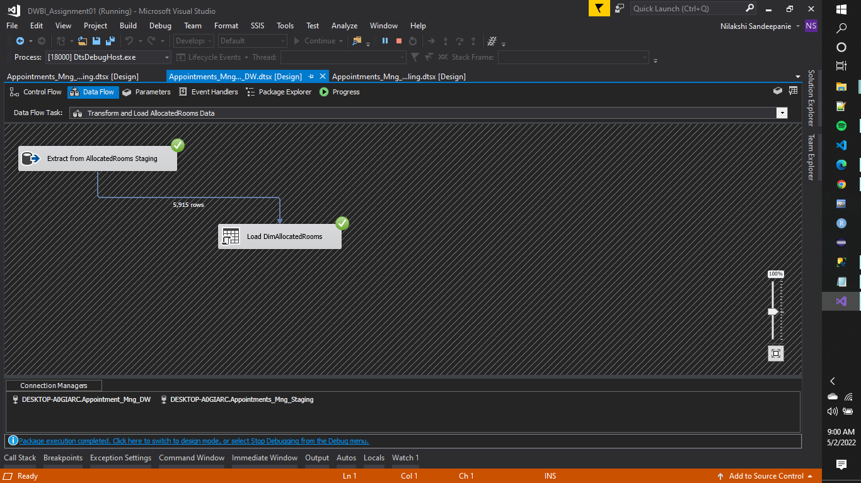

|  |  |  |
| --- | --- | --- |
| Staging Physicians Details  Staging Allocated Rooms Details    Allocated Rooms data is extracted from the Allocated Rooms table in source database and inserted to Allocated Rooms Staging Table | |  | | --- | | Physicians’ data is extracted from the Physicians table in source database and inserted to Physicians Staging Table | |
| Staging Ratings and Reviews details | |  | | --- | | Ratings and Reviews data is extracted from the Ratings and Reviews table in source database and inserted to Ratings and Reviews Staging Table | |

|  |  |  |  |
| --- | --- | --- | --- |
|  | |  | | --- | | Appointments data is extracted from the Appointments table in source database and inserted to Appointments Staging Table |   Staging Appointments details | |
|  | | Staging Patients Locations details    Patients Locations data is extracted from the Patients Locations text file and inserted to Patients Locations Staging Table |

|  |  |
| --- | --- |
|  |  |

After following the above steps and executing: (Executing Staging Package as itself)

When we run the created package several times, the staging tables get repeatedly loaded without truncating the data already available in the table. As a solution for this we configure EVENT HANDLERS.

*truncate table dbo. <table_name>*

Next step is data profiling, and it is done as shown below:

Loaded staging tables are used to analyze the way data should look like and the types of transformations needed to perform on data.

Every staging table is profiled and saved in a selected location.

Then ETL pipeline is used to read data from staging area tables and update corresponding data warehouse tables. Between staging area tables and source area tables there’s one to one mapping; Subsequently between staging area and warehouse tables only the updated rows of data are inserted. (Incremental load).

The below depicted order should be concerned when loading data from staging to warehouse due to the dependencies in between tables.



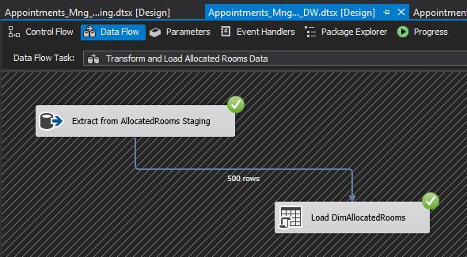Data was loaded from the Allocated Rooms Staging table 🡺 Allocated Rooms Dimension.

Extracted from Allocated Rooms Staging table and Loaded to Allocated Rooms Dimension table in DW package



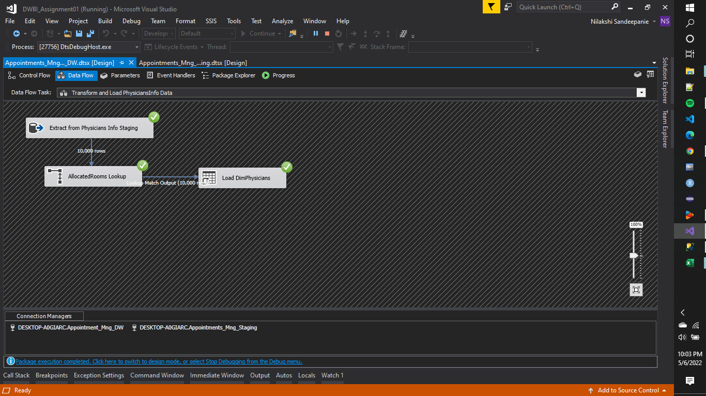Data was loaded from the Physicians Staging table 🡺 Physicians Dimension.

Extracted from Physicians Staging table and Loaded to Physicians Dimension table in DW package

Data was loaded from the Patients Locations Staging table 🡺 Patients Locations Dimension

Data was loaded from the Patients Staging table 🡺 Patients Dimension

As mentioned earlier under assumptions, Patients Info Dimension was considered as a slowly changing dimension. After merging patients table and patients’ locations table two data cleansing steps were applied.

Here, null values of gender column and age column are replaced by suitable values

The below mentioned columns were set as changing attributes:

1. Last Name
2. Age
3. Gender
4. Partner
5. Payment Method

After extracting data from the Patients staging table, it was sorted according to the PatientID and as it was identified as a slowly changing dimension and loaded into Patients Info Dimension table

Data was loaded from the Ratings and Reviews Staging table 🡺 Ratings and Reviews Dimension

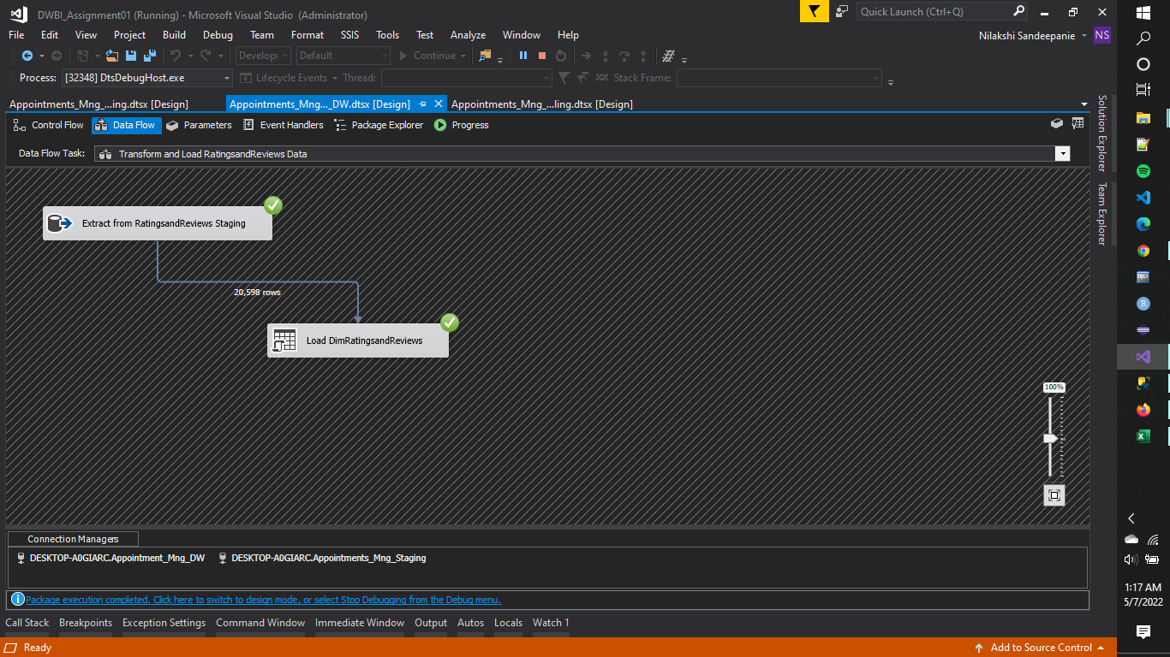

Extracted from Ratings and Reviews Staging table and Loaded to Ratings and Reviews Dimension table in DW package

The query used to create the date dimension is mentioned below:

|  |
| --- |
| BEGIN TRY  DROP TABLE [dbo].[DimDate]  END TRY  BEGIN CATCH  /*No Action*/  END CATCH  /**********************************************************************************/  CREATE TABLE [dbo].[DimDate]  ( [DateKey] INT primary key,  [Date] DATETIME,  [FullDateUK] CHAR(10), -- Date in dd-MM-yyyy format  [FullDateUSA] CHAR(10),-- Date in MM-dd-yyyy format  [DayOfMonth] VARCHAR(2), -- Field will hold day number of Month  [DaySuffix] VARCHAR(4), -- Apply suffix as 1st, 2nd ,3rd etc  [DayName] VARCHAR(9), -- Contains name of the day, Sunday, Monday  [DayOfWeekUSA] CHAR(1),-- First Day Sunday=1 and Saturday=7  [DayOfWeekUK] CHAR(1),-- First Day Monday=1 and Sunday=7  [DayOfWeekInMonth] VARCHAR(2), --1st Monday or 2nd Monday in Month  [DayOfWeekInYear] VARCHAR(2),  [DayOfQuarter] VARCHAR(3),  [DayOfYear] VARCHAR(3),  [WeekOfMonth] VARCHAR(1),-- Week Number of Month  [WeekOfQuarter] VARCHAR(2), --Week Number of the Quarter  [WeekOfYear] VARCHAR(2),--Week Number of the Year  [Month] VARCHAR(2), --Number of the Month 1 to 12  [MonthName] VARCHAR(9),--January, February etc  [MonthOfQuarter] VARCHAR(2),-- Month Number belongs to Quarter  [Quarter] CHAR(1),  [QuarterName] VARCHAR(9),--First,Second..  [Year] CHAR(4),-- Year value of Date stored in Row  [YearName] CHAR(7), --CY 2012,CY 2013  [MonthYear] CHAR(10), --Jan-2013,Feb-2013  [MMYYYY] CHAR(6),  [FirstDayOfMonth] DATE,  [LastDayOfMonth] DATE,  [FirstDayOfQuarter] DATE,  [LastDayOfQuarter] DATE,  [FirstDayOfYear] DATE,  [LastDayOfYear] DATE,  [IsHolidaySL] BIT,-- Flag 1=National Holiday, 0-No National Holiday  [IsWeekday] BIT,-- 0=Week End ,1=Week Day  [HolidaySL] VARCHAR(50),--Name of Holiday in US  [isCurrentDay] int, -- Current day=1 else = 0  [isDataAvailable] int, -- data available for the day = 1, no data available for the day = 0  [isLatestDataAvailable] int  )  GO  /********************************************************************************************/  --Specify Start Date and End date here  --Value of Start Date Must be Less than Your End Date  DECLARE @StartDate DATETIME = '01/01/1990' --Starting value of Date Range  DECLARE @EndDate DATETIME = '01/01/2099' --End Value of Date Range  --Temporary Variables To Hold the Values During Processing of Each Date of Year  DECLARE  @DayOfWeekInMonth INT,  @DayOfWeekInYear INT,  @DayOfQuarter INT,  @WeekOfMonth INT,  @CurrentYear INT,  @CurrentMonth INT,  @CurrentQuarter INT  /*Table Data type to store the day of week count for the month and year*/  DECLARE @DayOfWeek TABLE (DOW INT, MonthCount INT, QuarterCount INT, YearCount INT)  INSERT INTO @DayOfWeek VALUES (1, 0, 0, 0)  INSERT INTO @DayOfWeek VALUES (2, 0, 0, 0)  INSERT INTO @DayOfWeek VALUES (3, 0, 0, 0)  INSERT INTO @DayOfWeek VALUES (4, 0, 0, 0)  INSERT INTO @DayOfWeek VALUES (5, 0, 0, 0)  INSERT INTO @DayOfWeek VALUES (6, 0, 0, 0)  INSERT INTO @DayOfWeek VALUES (7, 0, 0, 0)  --Extract and assign various parts of Values from Current Date to Variable  DECLARE @CurrentDate AS DATETIME = @StartDate  SET @CurrentMonth = DATEPART(MM, @CurrentDate)  SET @CurrentYear = DATEPART(YY, @CurrentDate)  SET @CurrentQuarter = DATEPART(QQ, @CurrentDate)  /********************************************************************************************/  --Proceed only if Start Date(Current date ) is less than End date you specified above  WHILE @CurrentDate < @EndDate  BEGIN    /*Begin day of week logic*/  /*Check for Change in Month of the Current date if Month changed then  Change variable value*/  IF @CurrentMonth != DATEPART(MM, @CurrentDate)  BEGIN  UPDATE @DayOfWeek  SET MonthCount = 0  SET @CurrentMonth = DATEPART(MM, @CurrentDate)  END  /* Check for Change in Quarter of the Current date if Quarter changed then change  Variable value*/  IF @CurrentQuarter != DATEPART(QQ, @CurrentDate)  BEGIN  UPDATE @DayOfWeek  SET QuarterCount = 0  SET @CurrentQuarter = DATEPART(QQ, @CurrentDate)  END    /* Check for Change in Year of the Current date if Year changed then change  Variable value*/    IF @CurrentYear != DATEPART(YY, @CurrentDate)  BEGIN  UPDATE @DayOfWeek  SET YearCount = 0  SET @CurrentYear = DATEPART(YY, @CurrentDate)  END    -- Set values in table data type created above from variables  UPDATE @DayOfWeek  SET  MonthCount = MonthCount + 1,  QuarterCount = QuarterCount + 1,  YearCount = YearCount + 1  WHERE DOW = DATEPART(DW, @CurrentDate)  SELECT  @DayOfWeekInMonth = MonthCount,  @DayOfQuarter = QuarterCount,  @DayOfWeekInYear = YearCount  FROM @DayOfWeek  WHERE DOW = DATEPART(DW, @CurrentDate)    /*End day of week logic*/  /* Populate Your Dimension Table with values*/    INSERT INTO [dbo].[DimDate]  SELECT    CONVERT (char(8),@CurrentDate,112) as DateKey,  @CurrentDate AS Date,  CONVERT (char(10),@CurrentDate,103) as FullDateUK,  CONVERT (char(10),@CurrentDate,101) as FullDateUSA,  DATEPART(DD, @CurrentDate) AS DayOfMonth,  --Apply Suffix values like 1st, 2nd 3rd etc..  CASE  WHEN DATEPART(DD,@CurrentDate) IN (11,12,13)  THEN CAST(DATEPART(DD,@CurrentDate) AS VARCHAR) + 'th'  WHEN RIGHT(DATEPART(DD,@CurrentDate),1) = 1  THEN CAST(DATEPART(DD,@CurrentDate) AS VARCHAR) + 'st'  WHEN RIGHT(DATEPART(DD,@CurrentDate),1) = 2  THEN CAST(DATEPART(DD,@CurrentDate) AS VARCHAR) + 'nd'  WHEN RIGHT(DATEPART(DD,@CurrentDate),1) = 3  THEN CAST(DATEPART(DD,@CurrentDate) AS VARCHAR) + 'rd'  ELSE CAST(DATEPART(DD,@CurrentDate) AS VARCHAR) + 'th'  END AS DaySuffix,    DATENAME(DW, @CurrentDate) AS DayName,  DATEPART(DW, @CurrentDate) AS DayOfWeekUSA,  -- check for day of week as Per US and change it as per UK format  CASE DATEPART(DW, @CurrentDate)  WHEN 1 THEN 7  WHEN 2 THEN 1  WHEN 3 THEN 2  WHEN 4 THEN 3  WHEN 5 THEN 4  WHEN 6 THEN 5  WHEN 7 THEN 6  END  AS DayOfWeekUK,    @DayOfWeekInMonth AS DayOfWeekInMonth,  @DayOfWeekInYear AS DayOfWeekInYear,  @DayOfQuarter AS DayOfQuarter,  DATEPART(DY, @CurrentDate) AS DayOfYear,  DATEPART(WW, @CurrentDate) + 1 - DATEPART(WW, CONVERT(VARCHAR,  DATEPART(MM, @CurrentDate)) + '/1/' + CONVERT(VARCHAR,  DATEPART(YY, @CurrentDate))) AS WeekOfMonth,  (DATEDIFF(DD, DATEADD(QQ, DATEDIFF(QQ, 0, @CurrentDate), 0),  @CurrentDate) / 7) + 1 AS WeekOfQuarter,  DATEPART(WW, @CurrentDate) AS WeekOfYear,  DATEPART(MM, @CurrentDate) AS Month,  DATENAME(MM, @CurrentDate) AS MonthName,  CASE  WHEN DATEPART(MM, @CurrentDate) IN (1, 4, 7, 10) THEN 1  WHEN DATEPART(MM, @CurrentDate) IN (2, 5, 8, 11) THEN 2  WHEN DATEPART(MM, @CurrentDate) IN (3, 6, 9, 12) THEN 3  END AS MonthOfQuarter,  DATEPART(QQ, @CurrentDate) AS Quarter,  CASE DATEPART(QQ, @CurrentDate)  WHEN 1 THEN 'First'  WHEN 2 THEN 'Second'  WHEN 3 THEN 'Third'  WHEN 4 THEN 'Fourth'  END AS QuarterName,  DATEPART(YEAR, @CurrentDate) AS Year,  'CY ' + CONVERT(VARCHAR, DATEPART(YEAR, @CurrentDate)) AS YearName,  LEFT(DATENAME(MM, @CurrentDate), 3) + '-' + CONVERT(VARCHAR,  DATEPART(YY, @CurrentDate)) AS MonthYear,  RIGHT('0' + CONVERT(VARCHAR, DATEPART(MM, @CurrentDate)),2) +  CONVERT(VARCHAR, DATEPART(YY, @CurrentDate)) AS MMYYYY,  CONVERT(DATETIME, CONVERT(DATE, DATEADD(DD, - (DATEPART(DD,  @CurrentDate) - 1), @CurrentDate))) AS FirstDayOfMonth,  CONVERT(DATETIME, CONVERT(DATE, DATEADD(DD, - (DATEPART(DD,  (DATEADD(MM, 1, @CurrentDate)))), DATEADD(MM, 1,  @CurrentDate)))) AS LastDayOfMonth,  DATEADD(QQ, DATEDIFF(QQ, 0, @CurrentDate), 0) AS FirstDayOfQuarter,  DATEADD(QQ, DATEDIFF(QQ, -1, @CurrentDate), -1) AS LastDayOfQuarter,  CONVERT(DATETIME, '01/01/' + CONVERT(VARCHAR, DATEPART(YY,  @CurrentDate))) AS FirstDayOfYear,  CONVERT(DATETIME, '12/31/' + CONVERT(VARCHAR, DATEPART(YY,  @CurrentDate))) AS LastDayOfYear,  NULL AS IsHolidaySL,  CASE DATEPART(DW, @CurrentDate)  WHEN 1 THEN 0  WHEN 2 THEN 1  WHEN 3 THEN 1  WHEN 4 THEN 1  WHEN 5 THEN 1  WHEN 6 THEN 1  WHEN 7 THEN 0  END AS IsWeekday,  NULL AS HolidaySL, (case when @CurrentDate = convert(date, sysdatetime()) then 1 else 0 end), 0, 0  SET @CurrentDate = DATEADD(DD, 1, @CurrentDate)  END  /********************************************************************************************/    /*****************************************************************************************/  SELECT * FROM [dbo].[DimDate] |

**After loading data to all the dimensions and the fact table:**

The update procedure used to update Allocated Rooms is attached below:

The update procedure used to update Physicians is attached below:

The update procedure used to update Ratings and Reviews is attached below:

**Please find below a screenshot of the final fact table:**

As we are not maintaining a history of data, we only need to have the updated records in data warehouse. Either we can do a full load, or we can check for the unique data and update them.

In this assignment, I’ve used both these methods.

1- Allocated Rooms details and Physicians details are loaded by checking the latest values. For that I used two stored procedures. (Mentioned above)

2- After writing the stored procedure, ‘Allocated Rooms’ table is loaded first using a OLE DB Command task. Then the loaded table is merged with Physicians table by using a Look up instance.

3-When loading Ratings and Reviews table, I used a stored procedure. (Mentioned above)

4-Patients table

|  |  |
| --- | --- |
| The column Total is calculated the following way  Grand Total = Total Payment + VAT – Discount to be Added |  |
|  |
|  |
|  |
|  |
|  |
|  |
|  |
|  |
|  |
|  |

ETL development-Accumulating fact tables

[developed files are attached herewith]